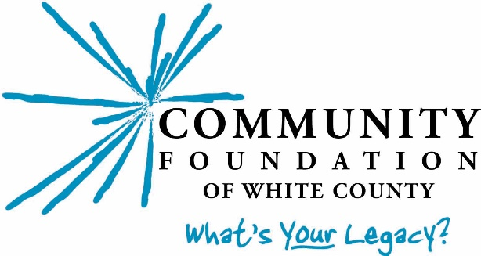

Community Grant Guidelines and Application Procedure
Fall 2021

Your Community Foundation of White County is committed to strengthening White County through charitable giving and is honored to serve as a vehicle for people who believe that investing in our community is important, relevant, and personal.
Our Community Grants are made possible by unrestricted donations to the Foundation from everyday people who care about our community. Whether large or small, these “use where they will best serve” gifts allow the Foundation’s Governing Council to offer grant opportunities to strengthen the social, cultural, educational, economic and physical well-being of White County.

Who may apply? In order to be eligible, your organization must have non-profit, 501c3 status.

What is funded? The Foundation is particularly interested in innovative approaches to solving community problems, maximizing unexpected opportunities, and supporting projects that evidence collaboration among agencies. Examples include:
- Start-up costs for a new or expanded project (should indicate plan for future support and sustainability)
- One-time projects that address a critical need
- Capital improvement projects that are beyond an applicant’s means
- Projects for which support from CFWC will enable applicants to obtain matching funding from other sources
We look for opportunities that will reach as many people as possible and will improve the ability of the organization to serve the community over the long term. Eligible programs/projects must serve the White County community.

What is not funded? Policies governing the Foundation generally preclude funding for:
Individuals
Endowments
Ongoing operating budgets, existing deficits, debt reduction, and multi-year, long-term
funding for projects
Religious activities or programs that are serving or appear to serve predominantly one
denomination and not the community at large (however, daycare/childcare programs, for example, if open to the public, would be eligible)
Political organizations or candidates
Programs or capital projects already completed

Please check with the Foundation if you have any questions as to eligibility for funding.

How much funding is available? A total of $25,000 has been allocated for Fall 2021 Community Grants to eligible nonprofits serving White County.

Think creatively!
How will your project enrich and strengthen your community?
Your grant application should be viewed as an opportunity to work with the Community Foundation as a partner involved in your idea (not simply a request for funding).

Submitting your grant application:

- Please call the Foundation before submitting a proposal to explain the nature of your grant, to gain an understanding of the Foundation’s priorities and funding capabilities for the year, and to ensure you have the current applications form.

- Complete the Grant Application form provided. All blanks MUST be filled in: if not applicable, please indicate. Your project narrative may not exceed three (3) pages and must address each of the questions listed. Please be kind and type your application using a size 11 font or larger. Please be certain to include all required attachments with your grant application.

- Please submit an original plus 5 copies of the grant application, including all attachments. Please do not staple or otherwise bind or package the application.

- Please include only the information requested. Any additional material will not be provided to the Community Grants Committee.

- The proposal should be submitted by a charitable organization. If you are submitting this proposal under the umbrella of another organization, that entity should complete the organization’s information. Please designate a primary contact person with his/her address and phone number.

- Your request will be assigned to a Community Grants Committee member. You may be contacted for further information or to schedule a site visit.

- Complete proposals must be IN the Community Foundation office by 5:00 p.m., Friday, October 15. Please return to:

Community Foundation of White County
(1001 Airport Rd.)
P.O. Box 1154
Monticello, IN 47960-1154
(574) 583-6911
www.cfwhitecounty.org

